**Assignment 1**

**Task:**

**1] In git repo create 3 branches and index.html file need to present in each branch.**

**2] In Jenkins master clone your repo. (every branch in different folder)**

**3] Create 3 jobs and in 3 slaves host the index.html with httpd server.**

**4] whenever you add anything in that index file. It will update the changes.**

**Step 1**

**Lunch master instance.(Preinstalled all required software)**

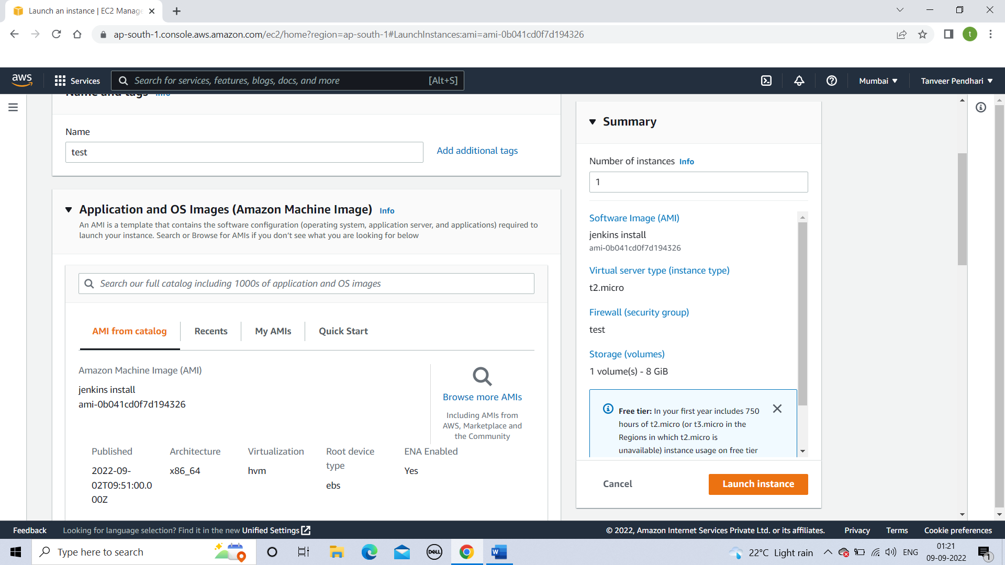

**Step 2**

**Starting Jenkins using tomcat**

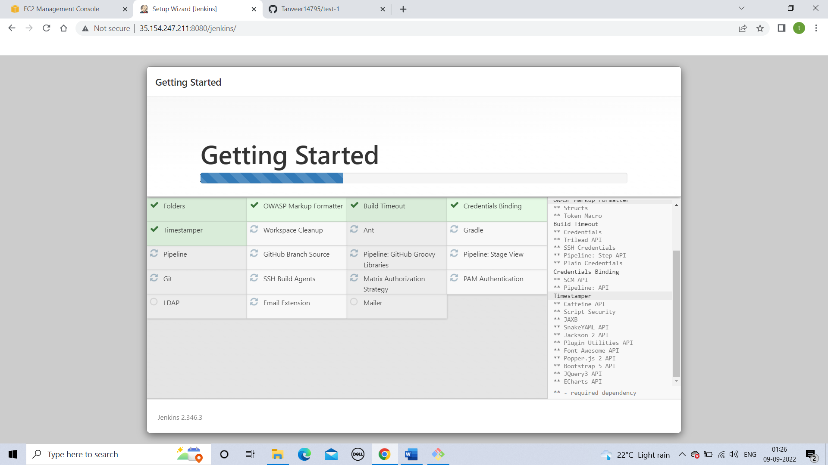

**Step 3**

**Launch a slave instance**

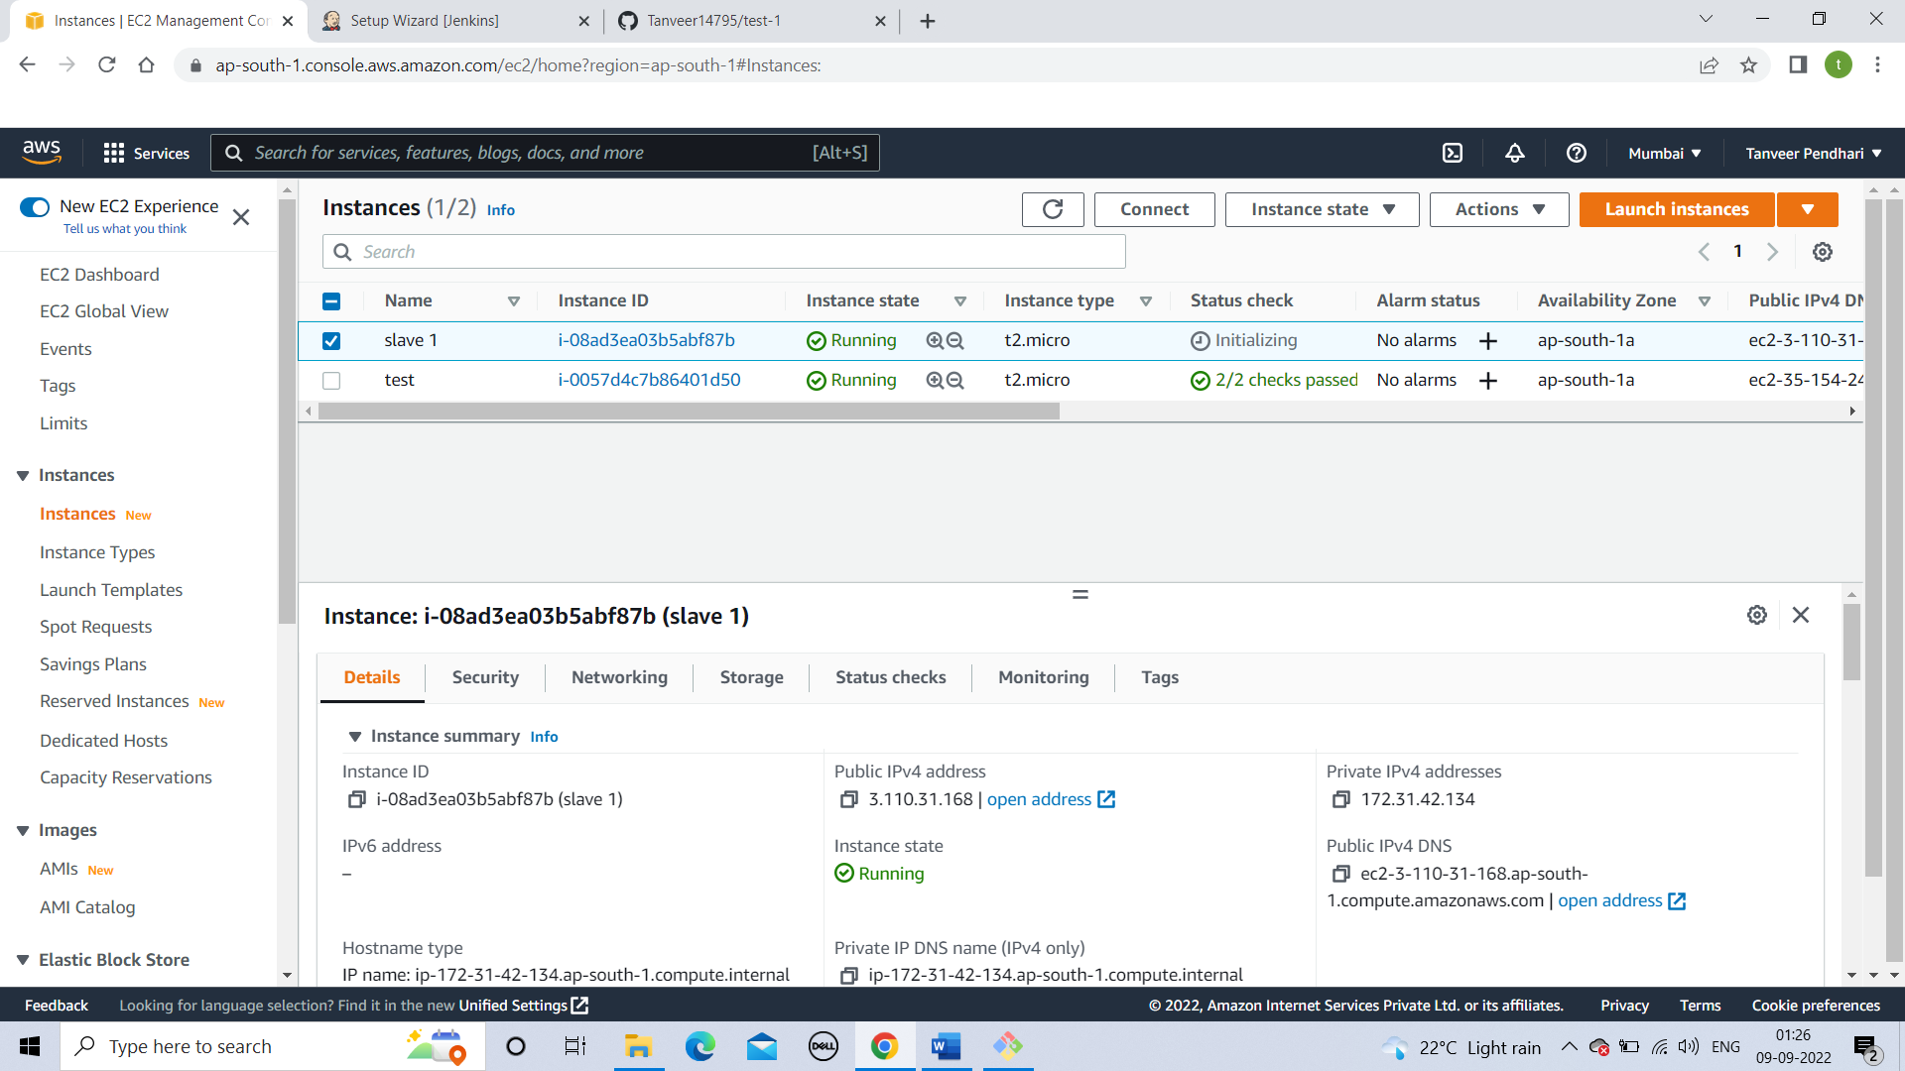

**Step 4**

**Installing java on slave.**

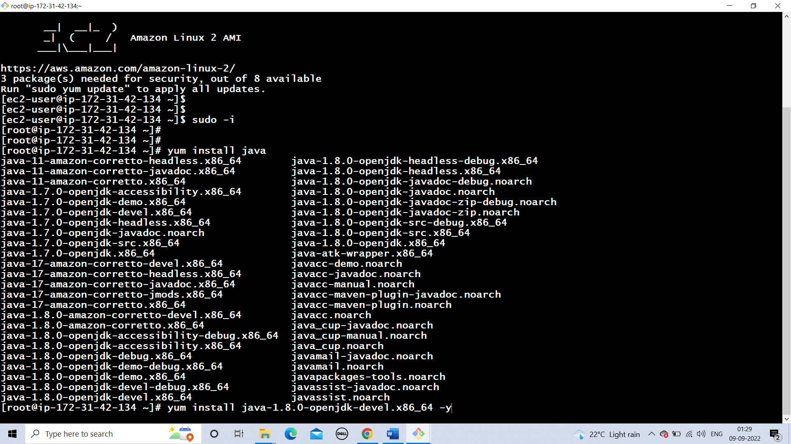

**Step 5**

**Add SSH credential (in manage Jinkins)**

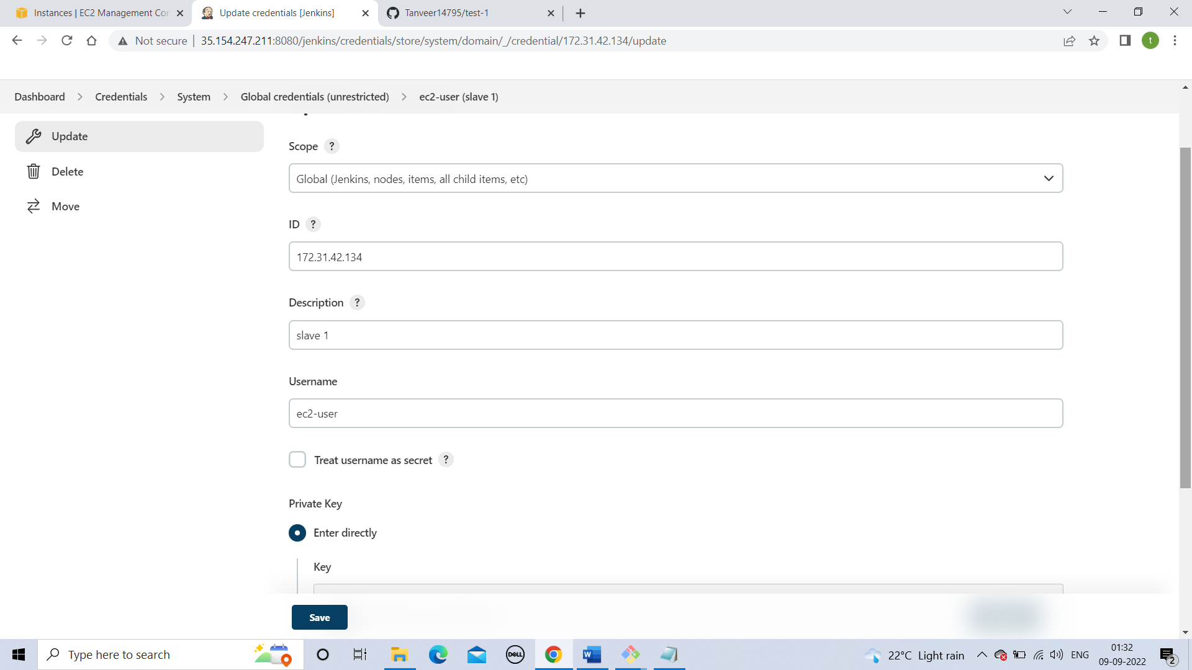

**Step 6**

**Create a node(add your slave details)**

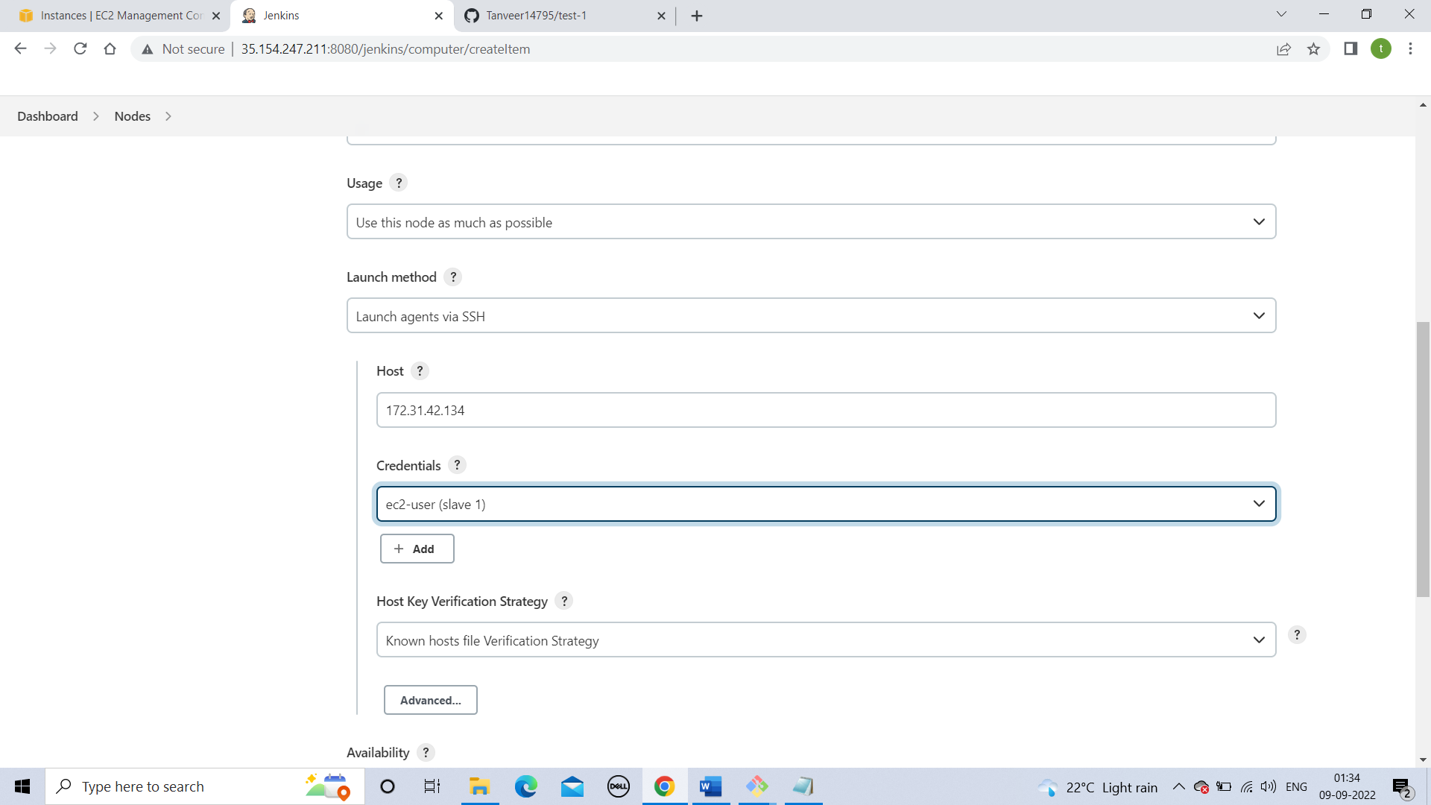

**Step 7**

**Trust your SSH host key.**

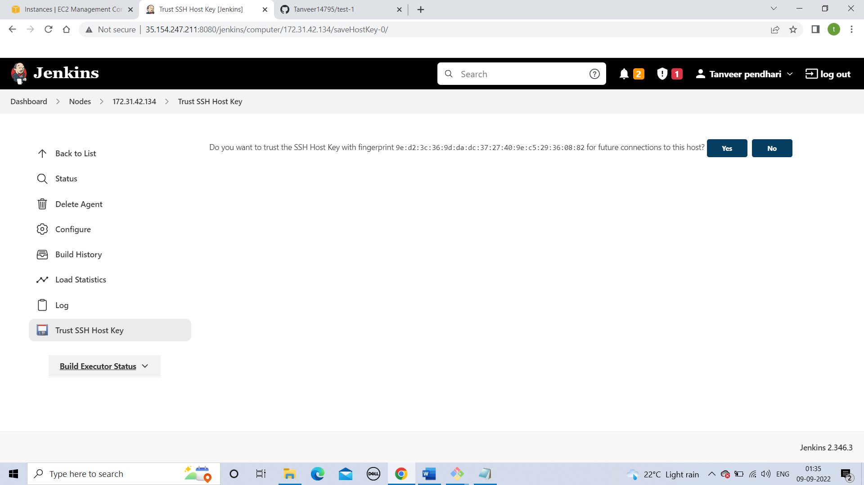

**Step 8**

**Create a new job with pipeline.**

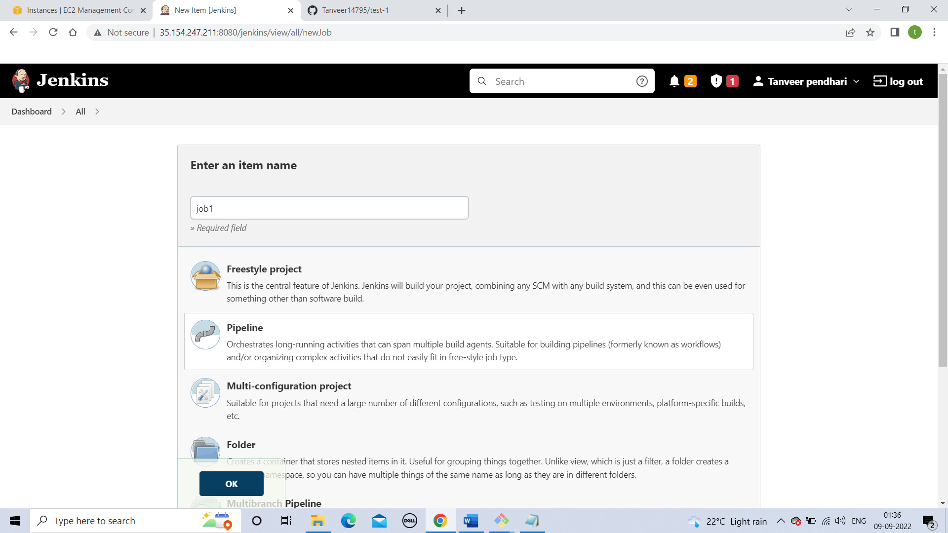

**Step 9**

**Create your pem file in master (I am going to transfer the file using SCP command)**

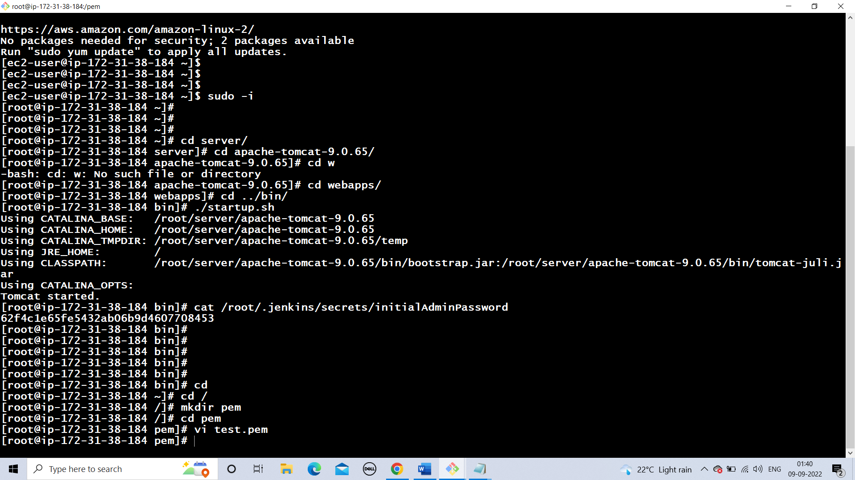

**Step 10**

**Write down pipeline code**

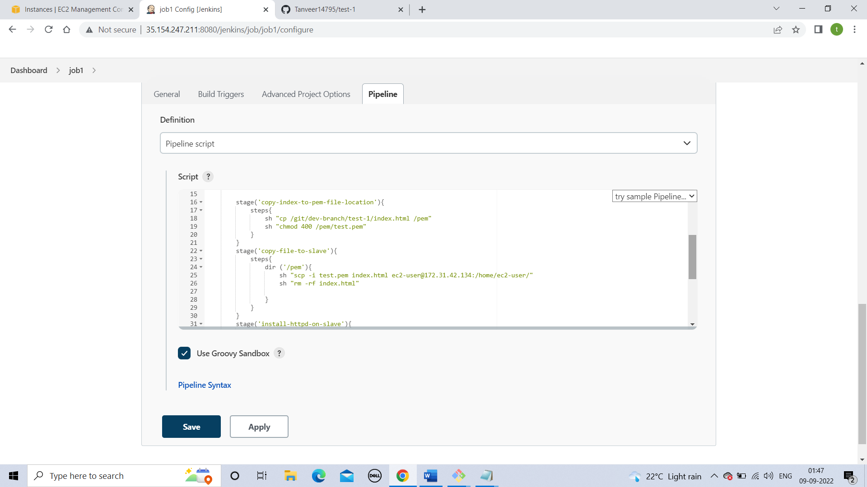

**Step 11**

**Run your code and check the errors.**

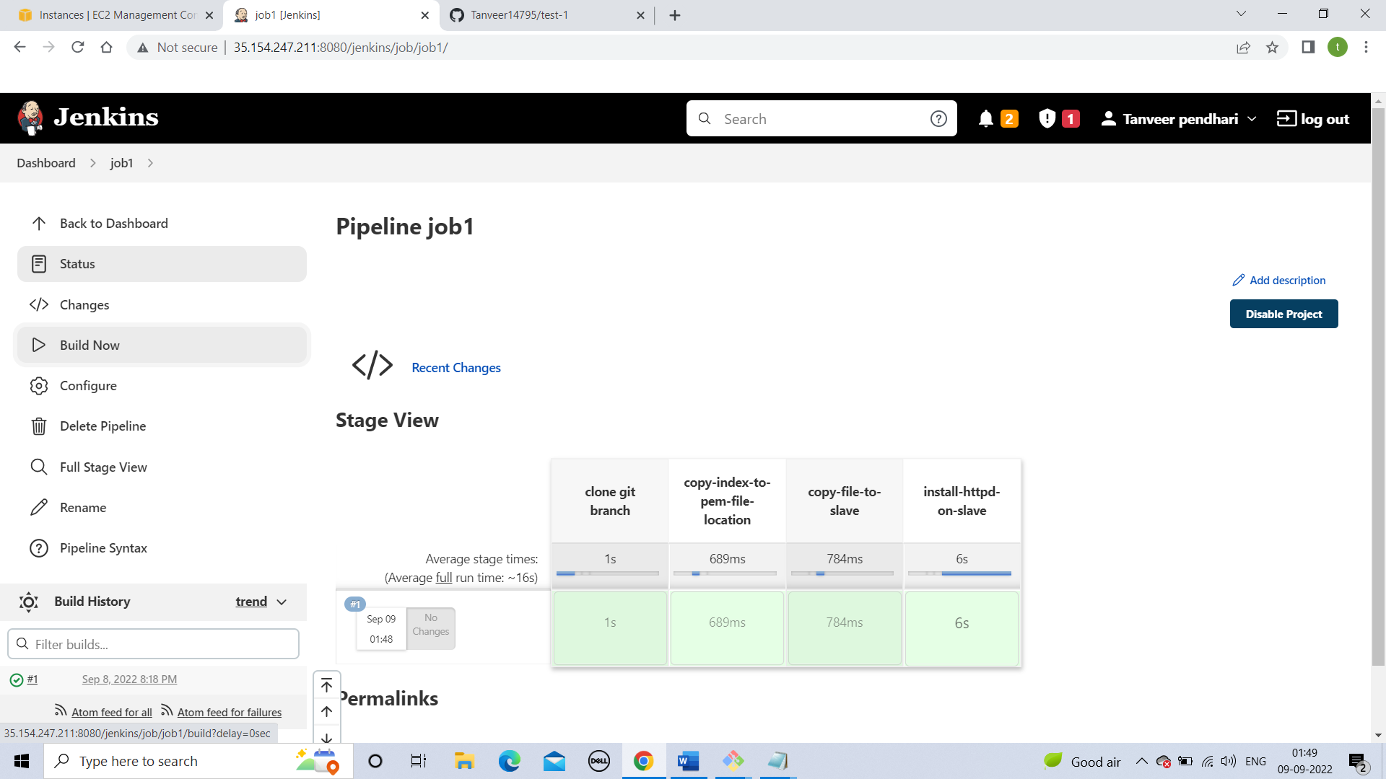

**Step 12**

**Host your slave public ip**

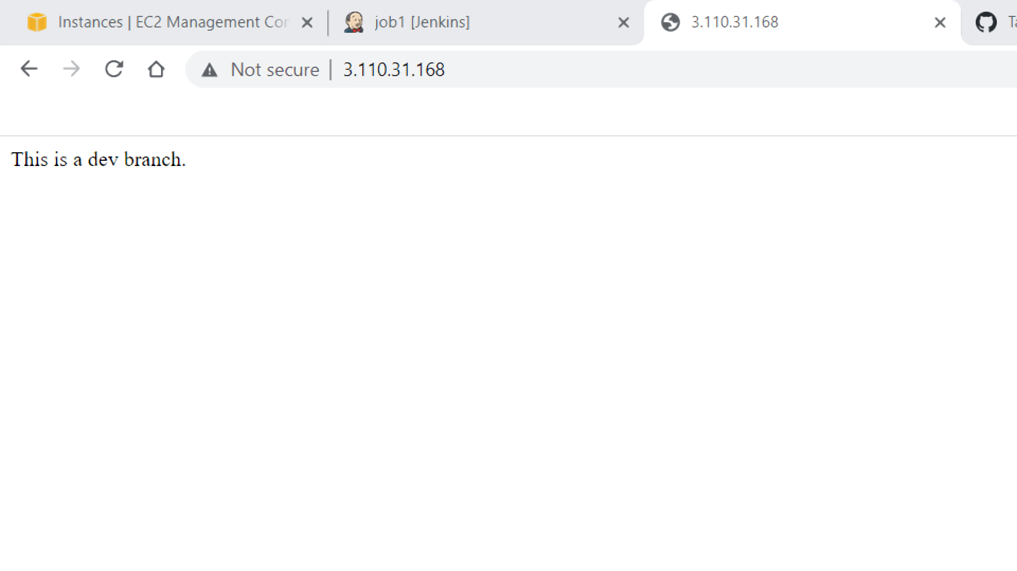

**Step 13**

**Adding same data in index file.**

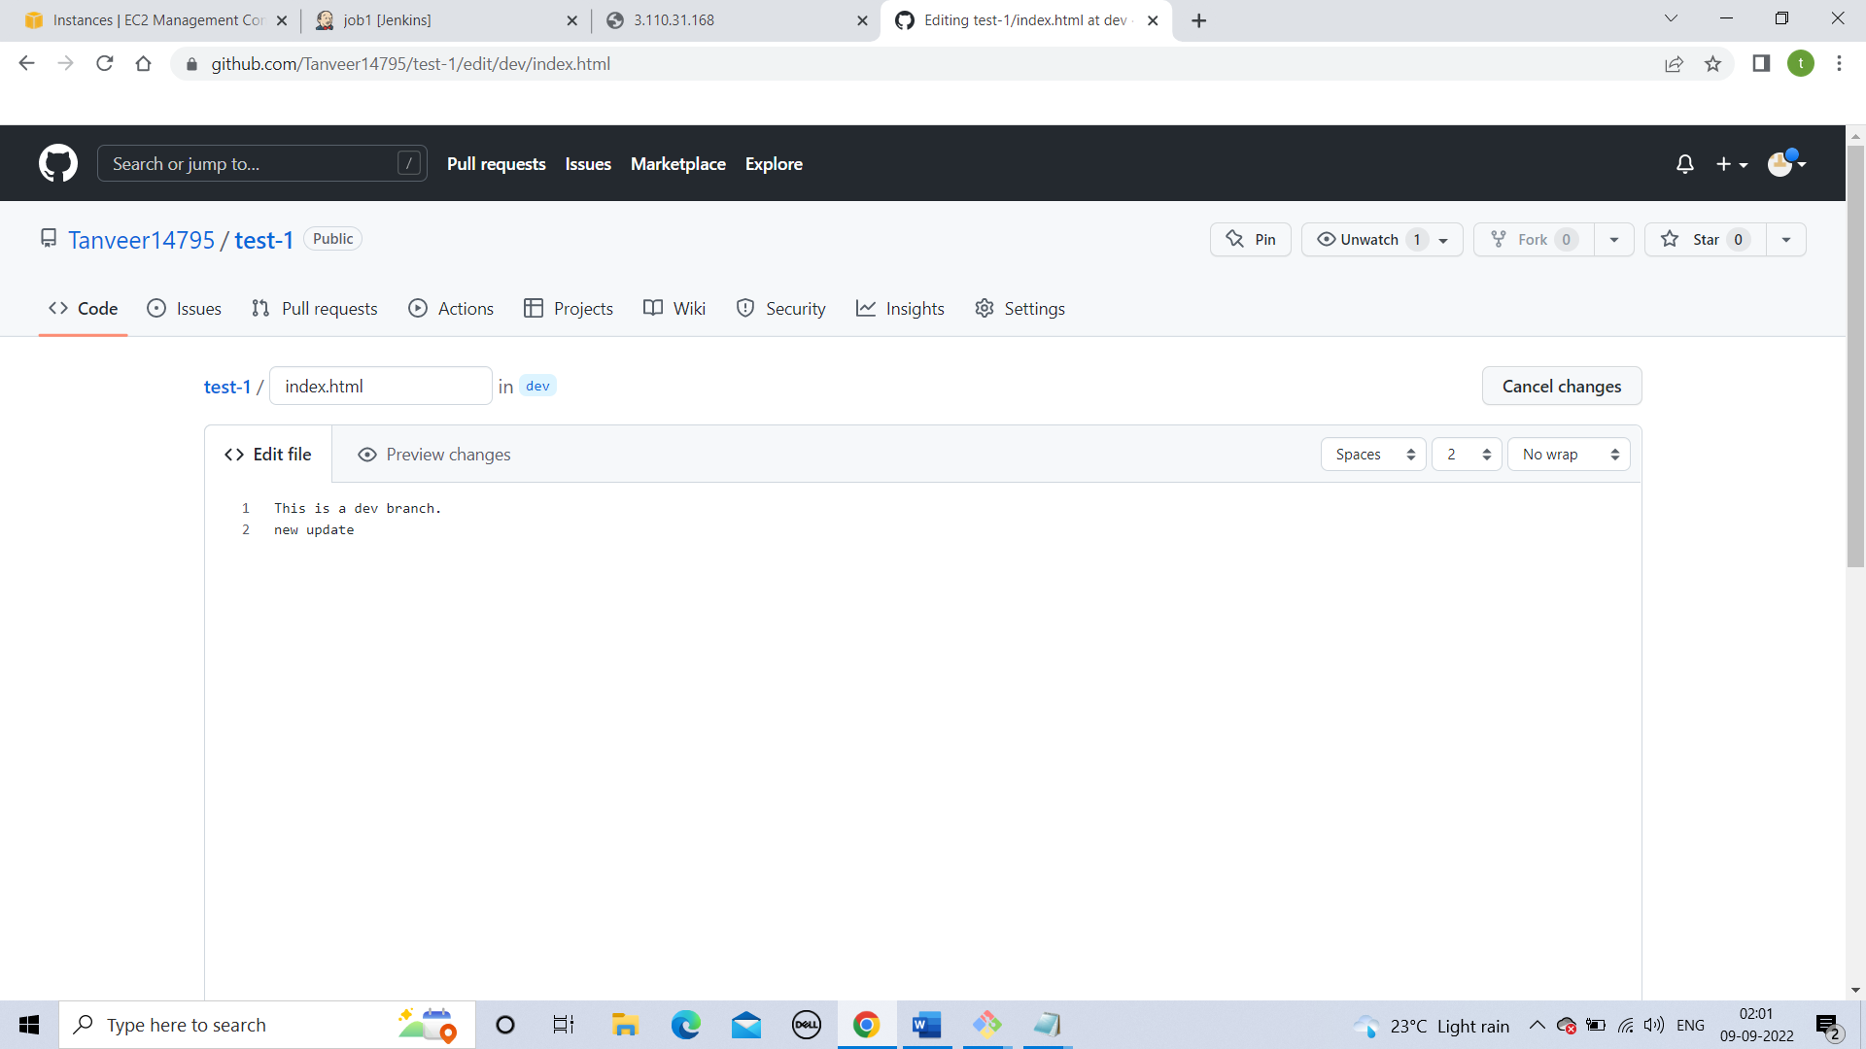

**Step 14**

**Build a job again**

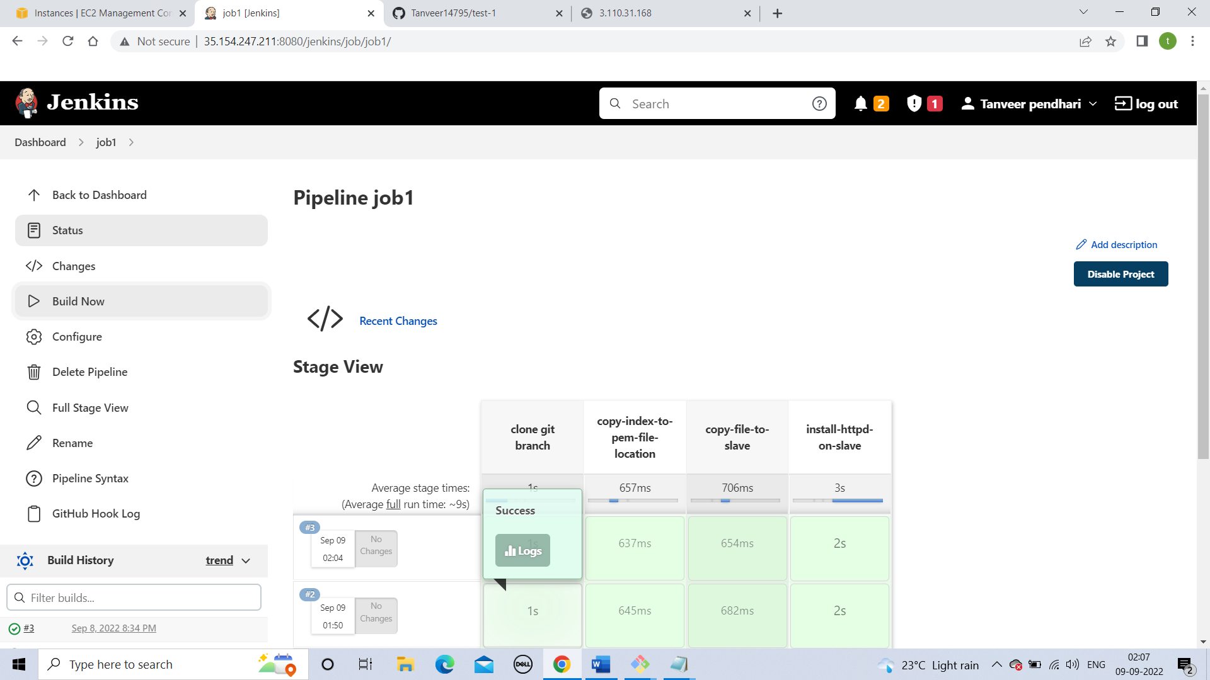

**Step 15**

**Check slaves public ip and check the updates.**

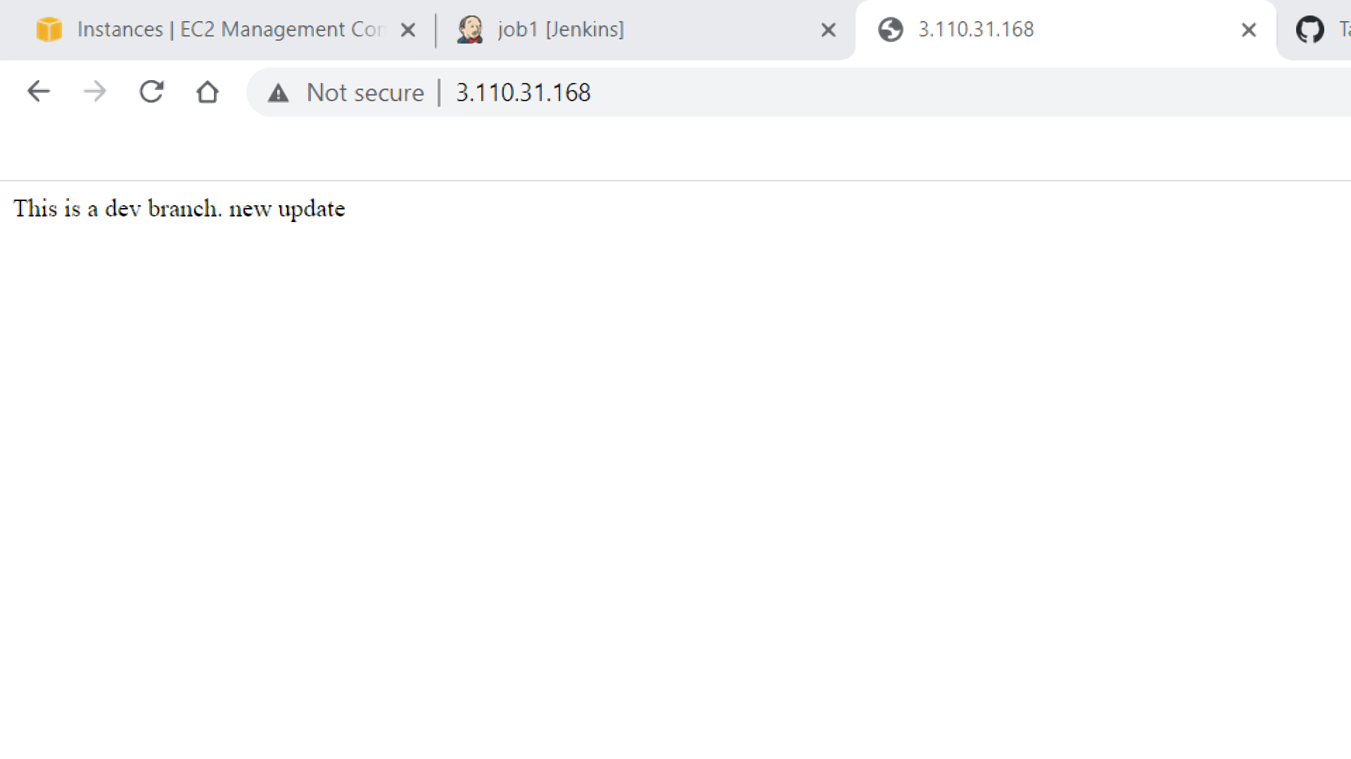

**Step 16**

**Create a two job accordingly for other two branches.**

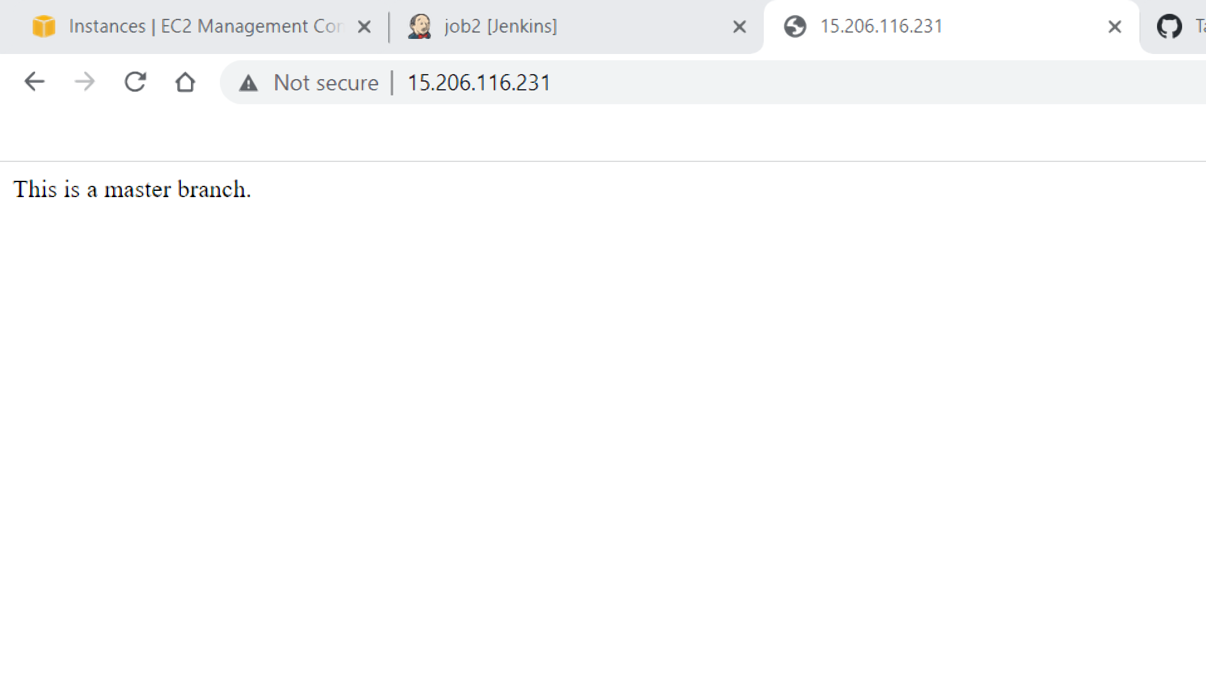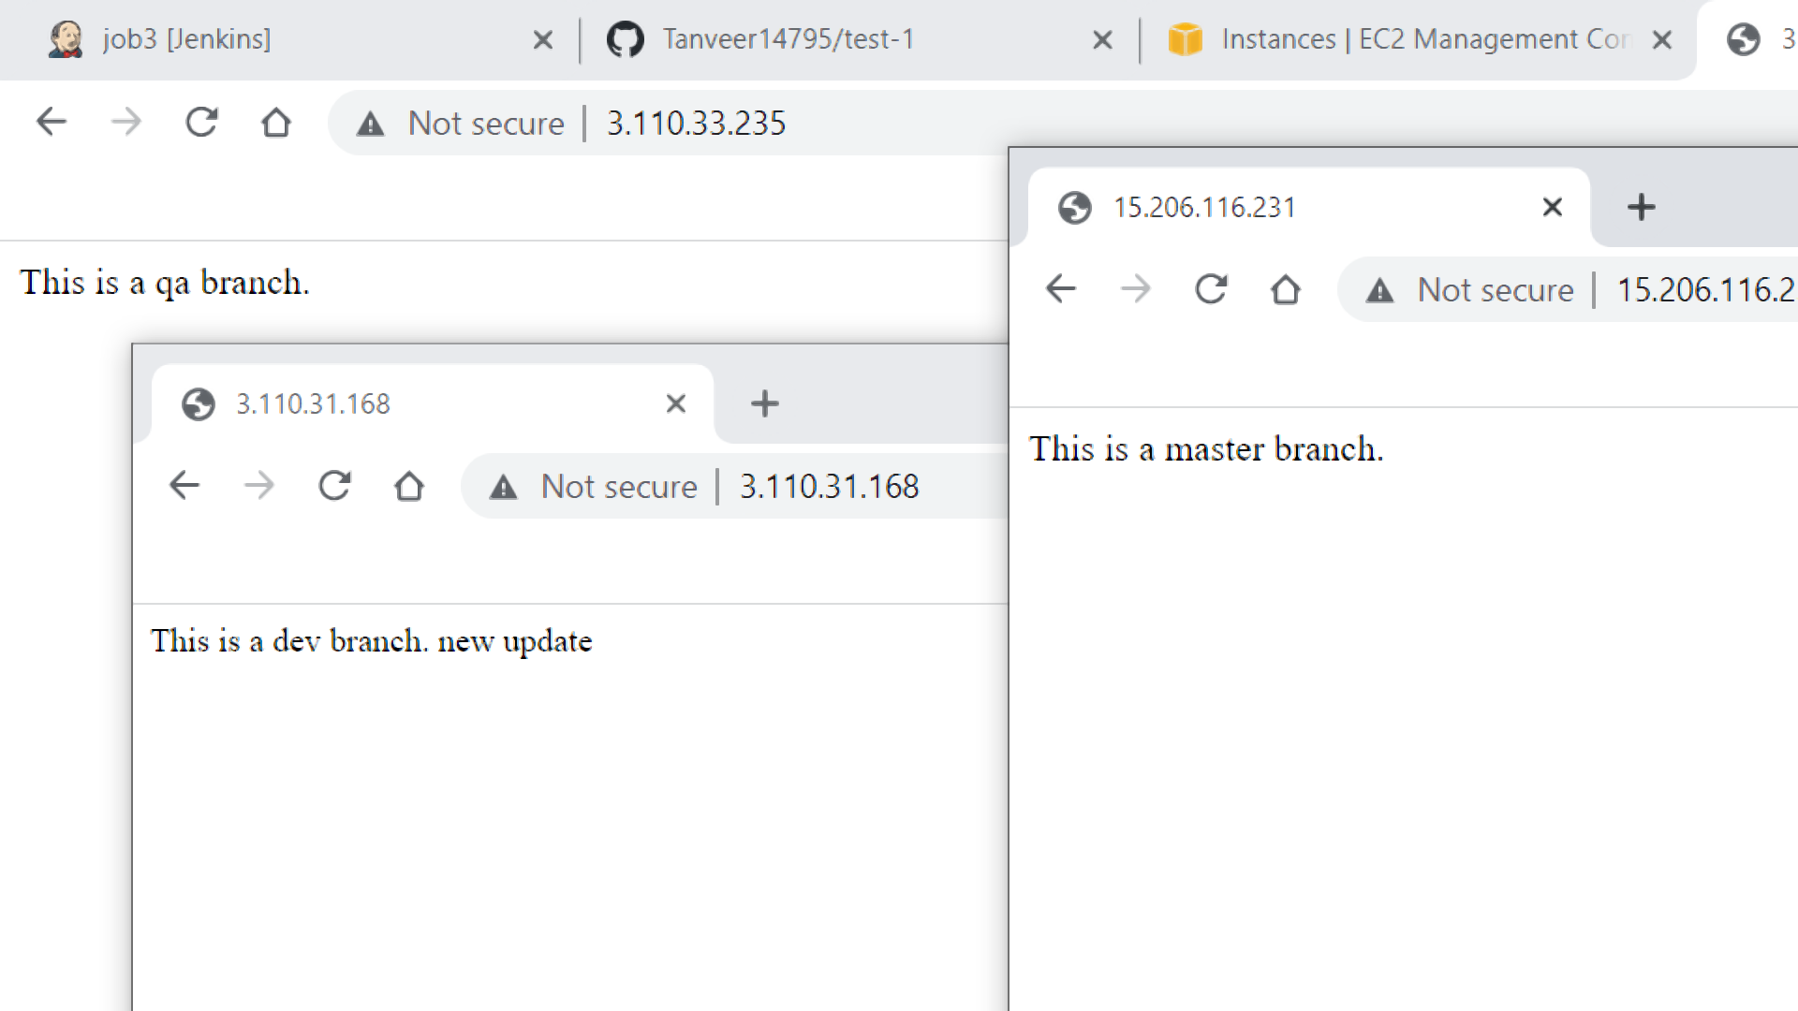

***Pipeline code***

**pipeline{**

**agent{**

**label{**

**label 'built-in'**

**customWorkspace '/git/dev-branch'**

**}**

**}**

**stages{**

**stage('clone git branch'){**

**steps{**

**sh "rm -rf *"**

**sh "git clone --single-branch --branch dev https://github.com/Tanveer14795/test-1.git"**

**}**

**}**

**stage('copy-index-to-pem-file-location'){**

**steps{**

**sh "cp /git/dev-branch/test-1/index.html /pem"**

**sh "chmod 400 /pem/test.pem"**

**}**

**}**

**stage('copy-file-to-slave'){**

**steps{**

**dir ('/pem'){**

**sh "scp -i test.pem index.html ec2-user@172.31.42.134:/home/ec2-user/"**

**sh "rm -rf index.html"**

**}**

**}**

**}**

**stage('install-httpd-on-slave'){**

**agent{**

**label{**

**label '172.31.42.134'**

**}**

**}**

**steps{**

**sh "sudo yum install httpd -y"**

**sh "sudo service httpd start"**

**sh "sudo chmod 755 /home/ec2-user/index.html"**

**sh "sudo cp /home/ec2-user/index.html /var/www/html/"**

**sh "sudo rm -rf /home/ec2-user/index.html"**

**}**

**}**

**}**

**}**